# Brainstorm

**TIP**

You can select a sticky note and hit the pencil [switch to sketch] icon to start drawing!

## Before you collaborate

A little bit of preparation goes a long way with this session. Here’s what you need to do to get going.

**10 minutes**

**1**

## Define your problem statement

What problem are you trying to solve? Frame your problem as a How Might We statement. This will be the focus of your brainstorm.

**5 minutes**

**2**

## Brainstorm

Write down any ideas that come to mind that address your problem statement.

**10 minutes**

**3**

## Group ideas

Take turns sharing your ideas while clustering similar or related notes as you go. Once all sticky notes have been grouped, give each cluster a sentence-like label. If a cluster is bigger than six sticky notes, try and see if you and break it up into smaller sub-groups.

**20 minutes**

**4**

## Prioritize

Your team should all be on the same page about what's important moving forward. Place your ideas on this grid to determine which ideas are important and which are feasible.

**20 minutes**

## After you collaborate

You can export the mural as an image or pdf to share with members of your company who might find it helpful.

**Quick add-ons**

# & idea prioritization

**A Team gathering**

Define who should participate in the session and send an invite. Share relevant information or pre-work ahead.

**PROBLEM**

**How might we [your problem statement]?**

**MOHAMMED SITHIK M**

**FILTERS FOR**

**Karthik Muneeswaran.M**

filters for different prices and sizes

**TIP**

Add customizable tags to sticky notes to make it easier to find, browse, organize, and categorize important ideas as themes within your mural.

SECURITY AND PRIVACY FOR CUSTOMERS

CATEGORIES FOR DIFFERENT GENDERS

**Aswanth R**

LIVE TRACKING OF GOODS

NOTIFICATIONS FOR

USERS

VERIFIED

M

Storre the

Managing users

1. **Share the mural**

**Share a view link** to the mural with stakeholders to keep

**CHATBOTS FOR**

**DIFFERENT**

PRODUCTS

customer

choices and

### Use this template in your own

1. **Set the goal**

**RECOMMENDATIONS PRICES AND**

**SIZES**

CREDIT

details

orders

Price tracker

Promote best details and offers

**category for different genders**

credit card and debit card payments

verified products

promote best deals

them in the loop about the outcomes of the session.

### brainstorming sessions so your team

can unleash their imagination and start shaping concepts even if you're not sitting in the same room.

**10 minutes** to prepare

**1 hour** to collaborate

**2-8 people** recommended

Think about the problem you'll be focusing on solving in the brainstorming session.

1. **Learn how to use the facilitation tools**

Use the Facilitation Superpowers to run a happy and productive session.

[**Open article**](https://support.mural.co/en/articles/2113740-facilitation-superpowers)

#### Key rules of brainstorming

To run an smooth and productive session

**HELP AND**

**SUPPORT**

SIGN IN USING FB/ GMAIL

CARD AND DEBIT CARD PAYMENTS

CATLOG FOR ITEMS

CASH ON DELIVERY

USER FRIENDLY UI

COUSTOMER

FEEDBACK

SIMPLE INTERFACE

filters for different prices and sizes

live tracking of goods

store the customer detail;s

Simple voice searching

user friendly ui

help and support

price tracker

and offers

Customer feedback

user friendly ui

security and privacy for customers

Help and support

LIVE TRACKING OF GOODS

**B Export the mural**

Export a copy of the mural as a PNG or PDF to attach to emails, include in slides, or save in your drive.

#### Keep moving forward

**Strategy blueprint**

Define the components of a new idea or strategy.

[**Open the template**](https://app.mural.co/template/e95f612a-f72a-4772-bc48-545aaa04e0c9/984865a6-0a96-4472-a48d-47639307b3ca)

**Customer experience journey map**

Understand customer needs, motivations, and

Stay in topic. Defer judgment.

Encourage wild ideas.

customer

feedback promote

best deals

VERIFIED PRODUCTS

#### Importance

If each of these tasks could get

obstacles for an experience.

[**Open the template**](https://app.mural.co/template/b7114010-3a67-4d63-a51d-6f2cedc9633f/c1b465ab-57af-4624-8faf-ebb312edc0eb)

**Strengths, weaknesses, opportunities & threats**

CREDIT CARD AND DEBIT CARD PAYMENT

Price tracker

Go for volume. If possible, be visual.

Listen to others.

and offers

done without any difficulty or cost, which would have the most positive impact?

Identify strengths, weaknesses, opportunities, and threats (SWOT) to develop a plan.

|  |  |
| --- | --- |
|  |  |
|  |  |

[**Open the template**](https://app.mural.co/template/6a062671-89ee-4b76-9409-2603d8b098be/ca270343-1d54-4952-9d8c-fbc303ffd0f2)

Store the customer details

**TIP**

Category for different genders

Participants can use their cursors to point at where sticky notes should go on the grid. The facilitator can confirm the spot by using the laser pointer holding the **H key** on the keyboard.

verified products

[**Share template feedback**](https://muralco.typeform.com/to/CiqaHVat?typeform-source=app.mural.co)

[**Share template feedback**](https://muralco.typeform.com/to/CiqaHVat?typeform-source=app.mural.co)

#### Feasibility

Regardless of their importance, which tasks are more feasible than others? (Cost, time, effort, complexity, etc.)

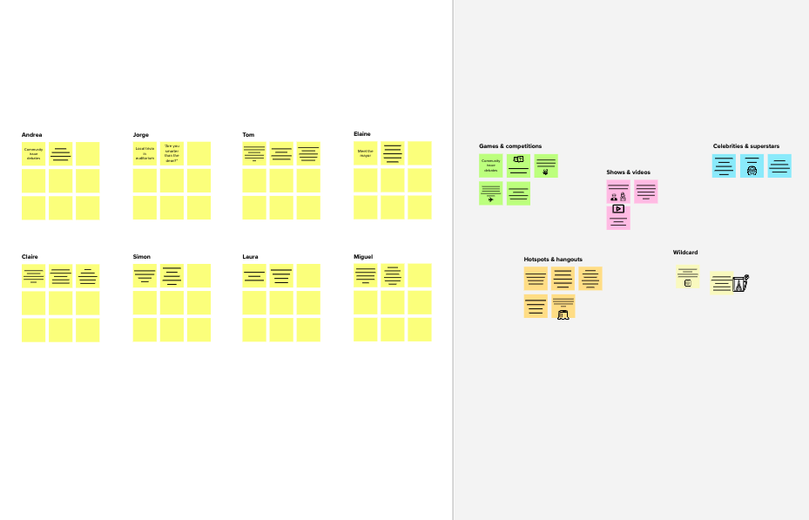

**Template**

**Need some inspiration?**

See a finished version of this template to kickstart your work.

[**Open example**](https://app.mural.co/template/e5a93b7b-49f2-48c9-afd7-a635d860eba6/93f1b98d-b2d2-4695-8e85-7e9c0d2fd9b9)